Oracle Cloud and EDI Integration

Industries for the Blind, Inc.

**ESSENDANT INBOUND & OUTBOUND RUNFLOW**

Contents

1 Overview 1

1.1 FTP Detials 1

1.2 Folder Structure 1

1.3 Production OIC URL 1

1.4 Production Oracle Application URL 1

2 Inbound 850 Run Flow 2

2.1 Import Sales Order 2

3 Outbound 856 Run Flow 3

3.1 Send Files to FTP 3

3.2 Monitor the Scheduled Process 4

4 Outbound 810 Run Flow 6

4.1 Send Files to FTP 6

4.2 Monitor the Scheduled Process 7

5 Inbound 997 Run Flow 8

5.1 Send Acknowledgement 8

# OVERVIEW

## FTP Details

IP Address: 12.188.254.136

Port Number: 22

UserName: essendant3

Password: ess01wa*!

## Folder Structure

850 Inbound EDI: /home/essendant3/in

850 Inbound XML: /home/essendant3/in/filesin

850 Inbound Processed XML: /home/essendant3/in/archive

850 Inbound Unprocessed/home/essendant3/in/unprocessed  
856 Outbound: /home/essendant3/out

810 Outbound: /home/essendant3/out

997 Outbound: /home/essendant3/in/997_Ack

## Dev OIC URL

<https://ibvi-oic-dev-ibvioic.integration.ocp.oraclecloud.com/ic/home/>

## Dev Oracle Application URL

<https://egti.fa.us2.oraclecloud.com>

# INBOUND 850 RUN FLOW:

Name of the Job: NIB_850_INBOUND_SALESORDER (3.20.0)

## Import Sales Order

1. NIB will place the edi files in the 850 inbound EDI folder of FTP. After that We are converting the .edi files into XML files and place those XML files into filesin folder of FTP.
2. Once if we have any files in the path mentioned above, the job will automatically pick the files and starts processing them as job was scheduled on hourly basis.
3. For Submitting the job manually click on How to Run button as shown below.



1. After clicking on How to run button we will have submit now shown.

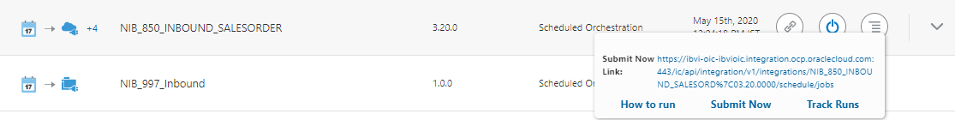

1. Click on Submit Now then the OIC job gets triggered and starts processing the XML files what we have in the /home/abilityone/in/filesin path.
2. If the file gets processed then the xml file will be moved to /home/abilityone/in/archive folder otherwise it will be moved to /home/abilityone/in/unprocessed folder.
3. As outbound 997 is an included process in the same job, it will produce a 997 Acknowledgement file based on the status of file import and place the 997 outbound file in /home/abilityone/out folder.

# OUTBOUND 856 RUN FLOW

Name of the Report: EDI 856 ABILITY ONE REPORT

Path for the Report: Shared Folders/Custom/Custom Reports/EDI Sell Side Reports/EDI 856/EDI 856 FOR ABILITY ONE/ EDI 856 ABILITY ONE REPORT

## Send Files to FTP

1. Navigate to the Report path and click on More and then click on schedule.

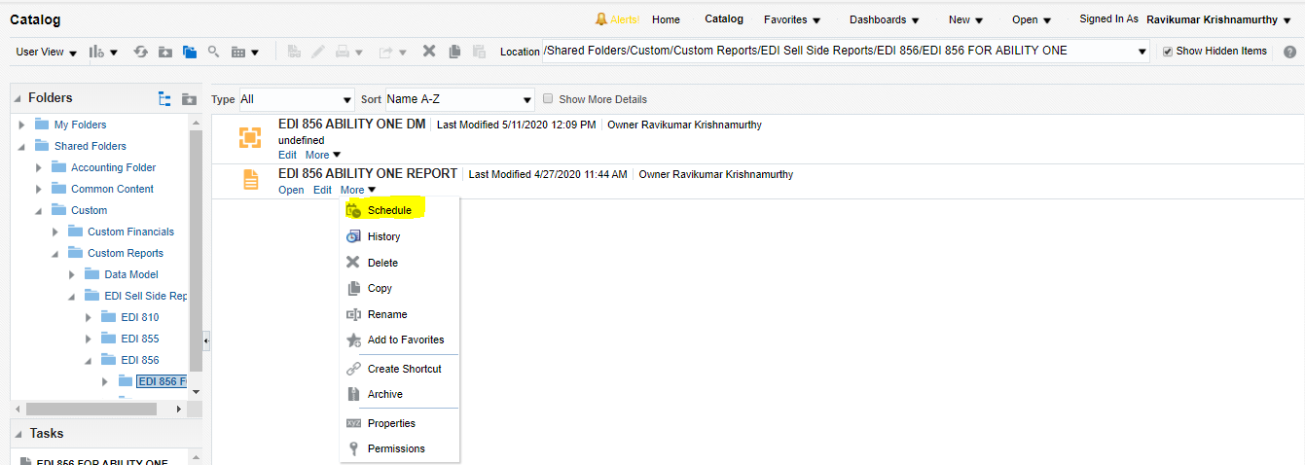

1. Provide the Date Range (Actual Ship Date) of the shipments that need to be sent and click on submit.

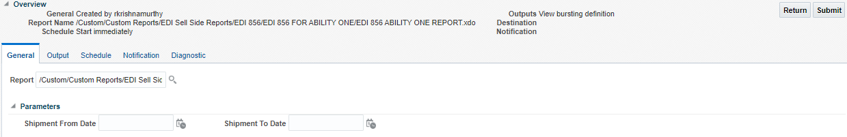

1. Provide the Report Job Name and click OK. The schedule process starts, and the files will be sent to /home/abilityone/out folder in the FTP Location.

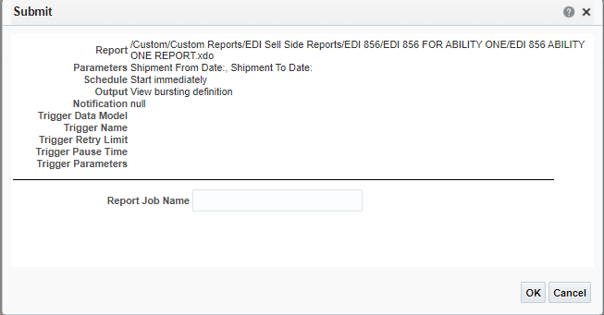

## Monitor the Scheduled Process

1. Navigate to the Report path and click on More and then click on history.

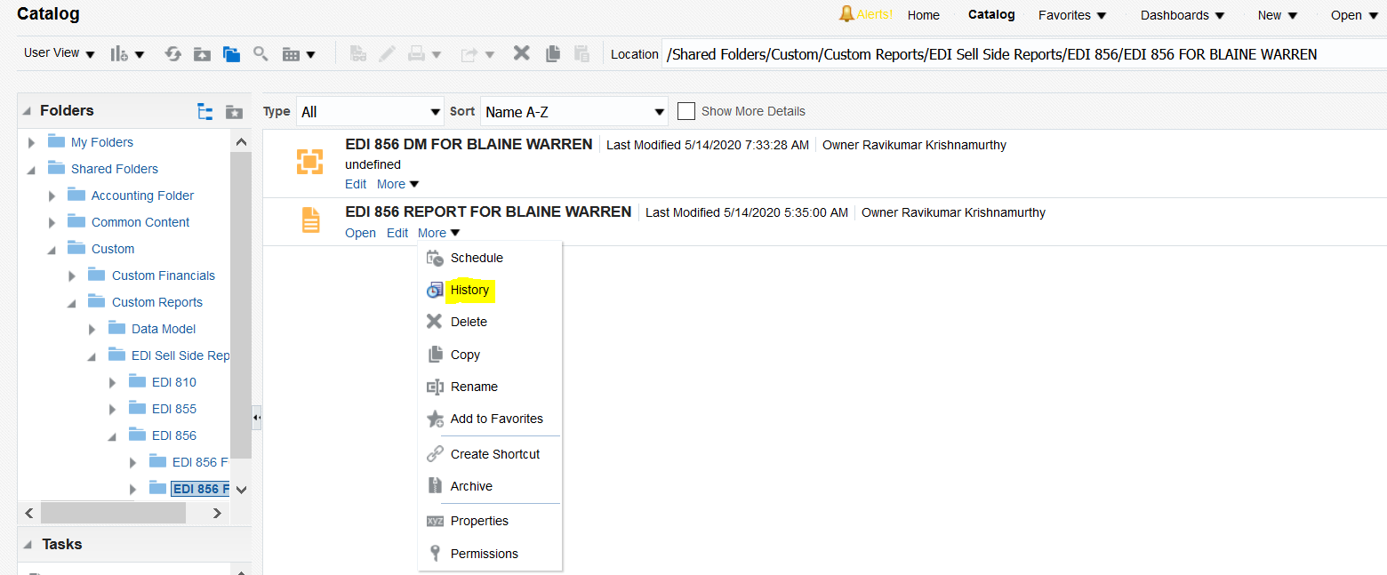

1. The Report Schedule Job history can be seen here with the Report Job Name and its status can be seen under status.

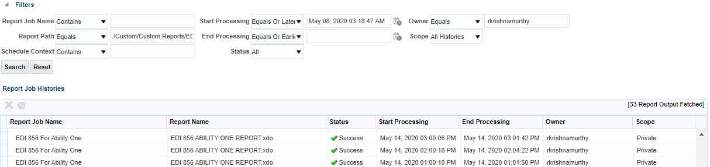

# OUTBOUND 810 RUN FLOW

Name of the Report: EDI 810 ABILITY ONE REPORT

Path for the Report: Shared Folders/Custom/Custom Reports/EDI Sell Side Reports/EDI 810/EDI 810 FOR ABILITY ONE/ EDI 810 ABILITY ONE REPORT

## Send Files to FTP

1. Navigate to the Report path and click on More and then click on schedule.

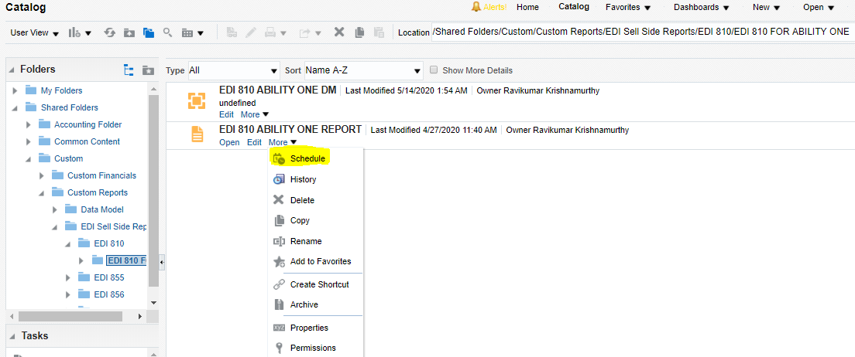

1. Provide the Date Range (Invoice Date) of the Invoices that need to be sent and click on submit.

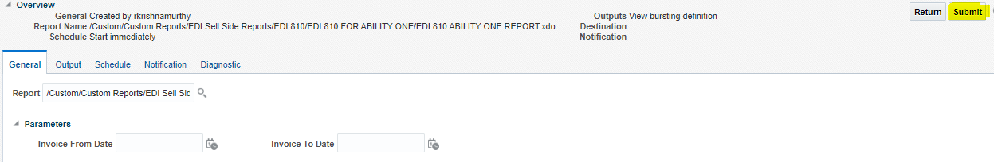

1. Provide the Report Job Name and click OK. The schedule process starts, and the files will be sent to /home/abilityone/out FTP Location.

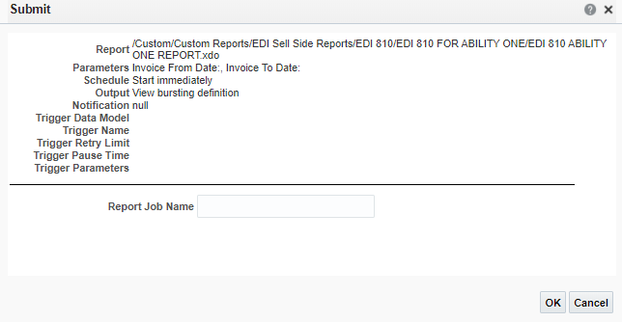

## Monitor the Scheduled Process

1. Navigate to the Report path and click on More and then click on history.

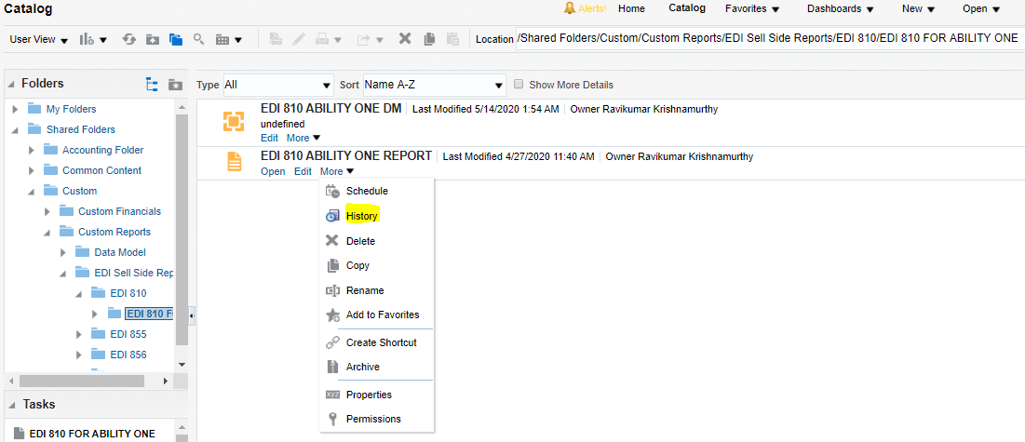

1. The Report Schedule Job history can be seen here with the Report Job Name and its status can be seen under status.

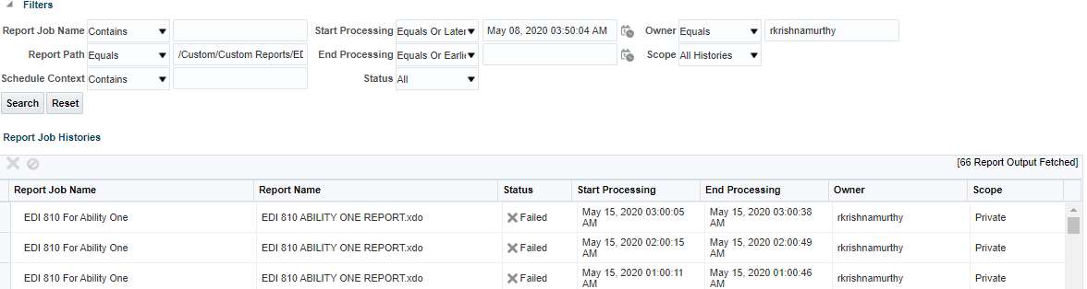

# INBOUND 997 RUN FLOW:

Name of the Job: NIB_997_INBOUND(1.0)

## Send Acknowledgement

1. NIB will place the edi files in the /home/abilityone/in/997 folder of FTP. After that We are converting the edi files into XML files and place those XML files into the /home/abilityone/in/NIB_997_Inbound folder of FTP and the processed edi files will be placed in /home/abilityone/in/archive/997_Inbound_edi folder of FTP.
2. Once if we have any files in /home/abilityone/in/NIB_997_Inbound folder then integration will automatically pick the 997 inbound xml files and process the.
3. For Submitting the job manually click on How to Run button as shown below.



1. After clicking on How to run button we will have submit now shown.

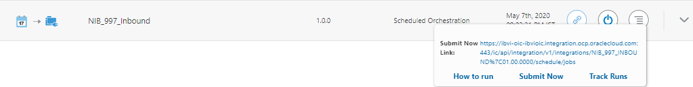

Click on Submit Now then the OIC job gets triggered and starts processing the XML files what we have in the /home/abilityone/in/NIB_997_Inbound/ path.

1. If the file gets processed, then a mail notification is sent to mentioned participents and the processed xml files will be moved to /home/abilityone/in/archive/997_Inbound_xml folder.